**NPRE 247, Modeling Nuclear Energy System**

Computer Project 3: Criticality and reactor feedback

Due: TBD

Use Serpent2 code to calculate criticality ~~and four factors~~ for a PWR pin cell. Use different moderator density to observe changes in reactivity ~~and four factors~~ for different Moderator/Fuel ratio.

Submit brief report with your results. See separate instructions on the report format. Do not send anything by email.

Report content

**1 page max (-10%)**

1. Report fuel enrichment (U-235 weight%) in the provided Serpent input (-10%)
2. Report element composition of cladding and element atom%. (-10%)
3. Report optimum Moderator/Fuel ratio (number of H atoms to U atoms) (-10%)
4. Plot parameter vs Moderator/Fuel ratio (number of H atoms to U atoms) for a wide range of Moderator/Fuel ratio, all on the same figure:
   * kinf vs Moderator/Fuel ratio (-10%)
   * ~~Fast fission factor vs Moderator/Fuel ratio (-10%)~~
   * ~~Resonance escape probability vs Moderator/Fuel ratio (-10%)~~
   * ~~Thermal utilization factor vs Moderator/Fuel ratio (-10%)~~
   * ~~Thermal fission factor vs Moderator/Fuel ratio (-10%)~~

**1 page max (-10%)**

1. Complete Serpent input with optimum Moderator/Fuel ratio (-10%)

 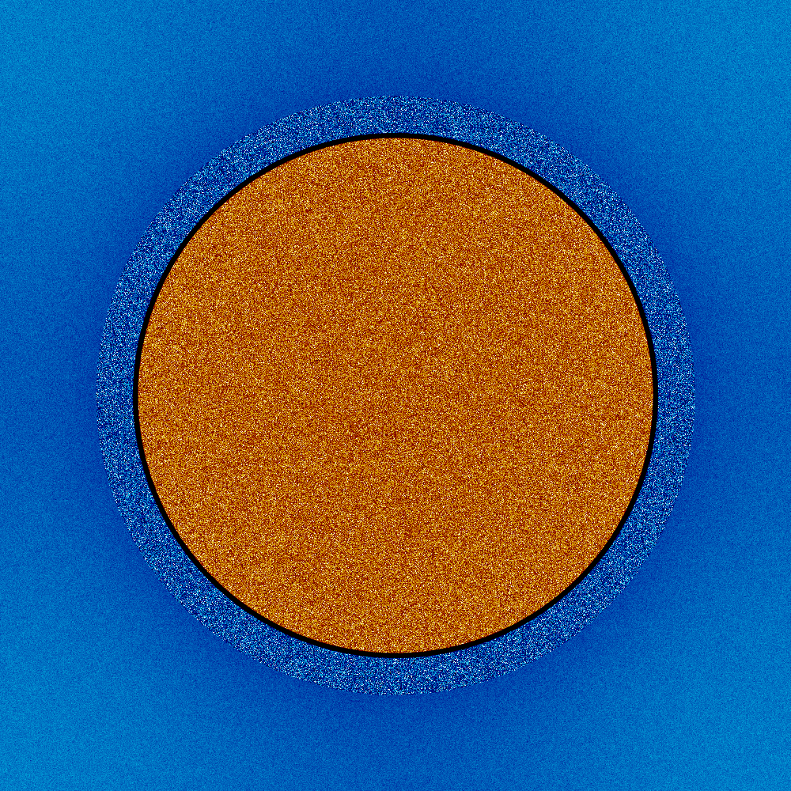

**Pin cell description**

Geometry

Fuel pellet radius 0.46955 mm

Cladding inner radius 0.47910 mm

Cladding outer radius 0.54640 mm

Pin pitch 1.44270 mm

Pin height 1.0 cm

Operating conditions

Fuel temperature 900 K

Cladding temperature 600 K

Moderator temperature 550 K (fixed, independent of moderator density)

Moderator density variable

Fuel composition: UO2, enrichment (mass%) to be determined by the student

mat fuel -10.21 | *mass density, g/cm3*

92235.09c 0.005000 | *U-235 atom%*

92238.09c 0.328333 | *U-238 atom%*

8016.09c 0.666667 | *O-16 atom%*

Moderator composition: H2O

mat water -1.000 moder lwtr 1001 | *mass densit*y*, g/cm3*

1001.06c 0.666667 | *H-1 atom%*

8016.06c 0.333333 | *O-16 atom%*

Cladding composition: elements and atom% to be determined by the student

mat clad -6.560 | *mass density, g/cm3*

40000.06c -0.9823 | *element mass%*

50000.06c -0.0145 | *element mass%*

26000.06c -0.0021 | *element mass%*

24000.06c -0.0010 | *element mass%*

72000.06c -0.0001 | *element mass%*

**Relevant output in “…_res.m”**

IMP_KEFF (idx, [1: 2]) = [ *k_eff uncertainty* ];

~~% Six-factor formula:~~

~~SIX_FF_ETA (idx, [1: 2]) = [~~ *~~thermal_fission~~**~~uncert~~* ~~];~~

~~SIX_FF_F (idx, [1: 2]) = [~~ *~~thermal_utilization~~**~~uncert~~* ~~];~~

~~SIX_FF_P (idx, [1: 2]) = [~~ *~~resonance_escape~~**~~uncert~~* ~~];~~

~~SIX_FF_EPSILON (idx, [1: 2]) = [~~ *~~fast_fission~~**~~uncert~~* ~~];~~

~~SIX_FF_KINF (idx, [1: 2]) = [~~ *~~k_inf~~**~~uncert~~* ~~];~~

For complete description of the input and output, see Serpent manual.